Seabird Apps Project Proposal

Sean Cann

# **Statement of Problem**

Seabird Apps has produced a number of organizational smartphone apps, including our most successful, the Dartmouth Student app, which currently has over 4,000 downloads and 2,000 active users. Our mission is to build similar apps for schools and other institutions, providing high quality at low cost. So far, we have built our apps using the software of [Red Foundry](https://studio.redfoundry.com/). The benefit of this is that we are able to create new apps in a matter of hours by basing them off previous ones. The problem with this, though, is that we must rely on this lesser-known third-party software which has fairly limited functionality.

This project with the DALI Lab is fairly straightforward. Starting with our Dartmouth Student iPhone app as a guide, build a cross-platform template smartphone app that can be easily changed to fit the needs of a particular school. The final product should be a template project (presumably built in React Native) that a Seabird Apps developer can copy-paste and easily edit to create a new app for a school in a couple hours time or less. In working with DALI, we also expect to make a number of improvements on our original design, ultimately resulting in products that will be of tremendous benefit to our client schools and organizations now and years into the future.

# **Stakeholders**

* Sean Cann ‘17 and Tyler Fisher ‘17, the partners and directors of Seabird Apps
* The DALI Lab
* The rest of the Seabird Apps team (around 5 additional student members)
* Students who currently use the Dartmouth Student iPhone app
* Schools who will work with Seabird Apps to have apps built for their community
* Students, alumni, prospective students, parents, and anyone else who will use future apps built by Seabird Apps

# **Solution Proposal**

Our team is going to take the next ten weeks to address the following issues and explain how we are going to solve these issues:

* Build a basic cross-platform smartphone app that can be easily altered to fit any school. This involves a number of modules on the frontend, as well as a backend that provides all data for these modules.

# **Timeline**

* Design
  + sketches (2/8)
  + wireframe/sitemap (2/15)
  + mockups (2/22)
* Develop
  + architecture and stack definition (date)
  + Alpha – weekly sprints (2/8)
    - at this stage most of the basic functionality is in place
  + Beta – weekly sprints (2/22)
    - at this stage all of the functionality is in place
    - design and styling are incorporated
* Deliver (3/5)
  + demo (?)
  + bug fixes and handoff to next stage/production (date)

# **General Feature Specifications**:

* Login screen
* Home screen with six modules
* More screen with a flexible number of additional modules
* User customization of Home and More screens
* Webview module
* User settings module
* Text, image, and buttons module
* Food module
* Sponsorship functionality (for local businesses, etc)

# **Team**:

* Ijemma Onwuzulike ‘19: Developer, PM
* Sean Cann ‘17: Developer, PM, Partner
* Tyler Fisher ‘17: Developer, Partner
* Will Kaufman ‘20: Developer (backend)
* Emma Demers ‘20: Designer
* Shuoqi Chen ‘18: Designer
* Armin Mahban ‘17: Mentor

# 

# 

# **DALI & Our Process**:

DALI Projects occur in five phases. While the timing may be different for each project, the sequence of steps remains the same. Each phase is essential to a project’s success:

Discover → Define → Design → Develop → Deliver



I. Discover  
In the *Discover* phase, the team works to quickly understand the problem, the users and stakeholders involved, and the potential scope.

II. Define  
In the *Define* phase the team uses this new, deeper understanding of the issue to reframe and clarify the problem and draft a solution.

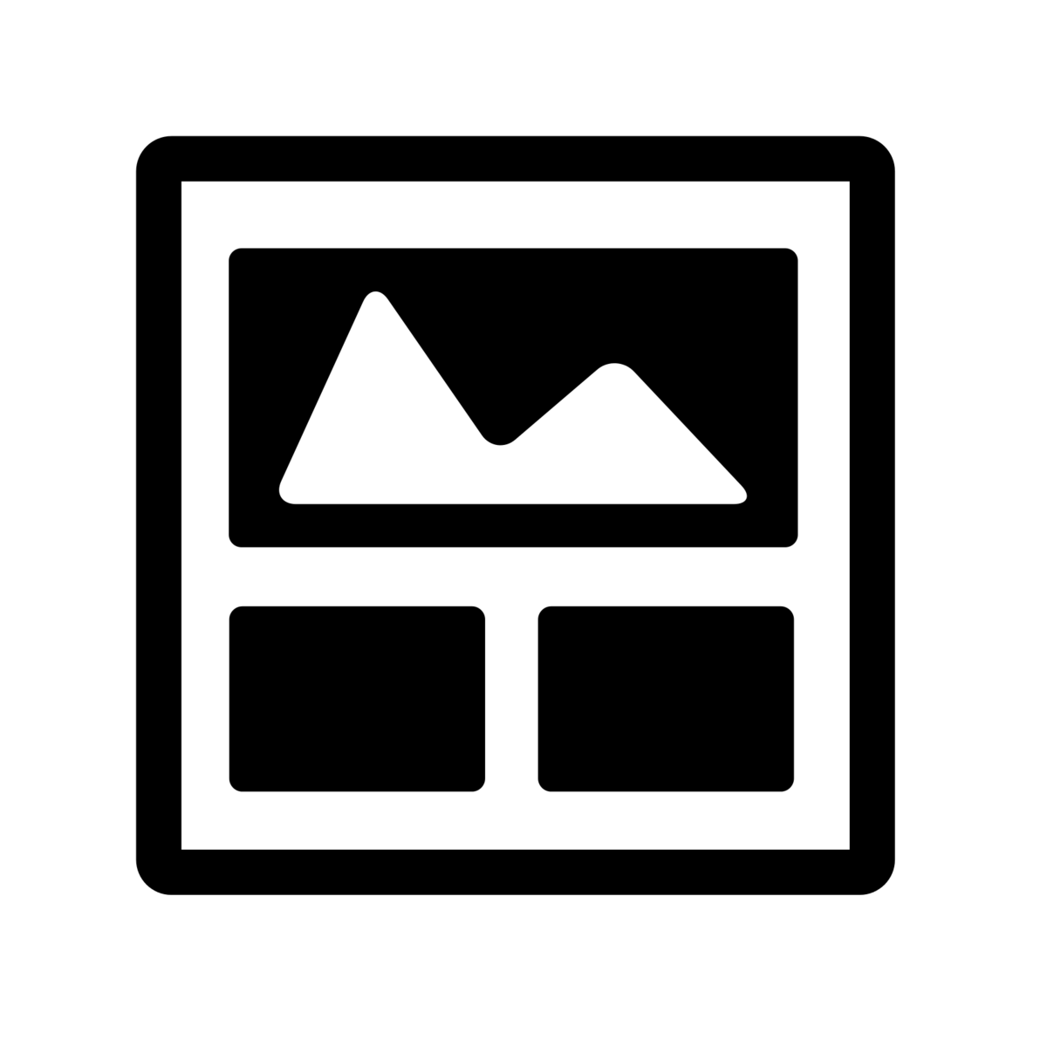

III. Design  
In the *Design* phase, the team fleshes out the proposed solution, moving from the user experience, to the structure and interface, and finally to the look & feel.

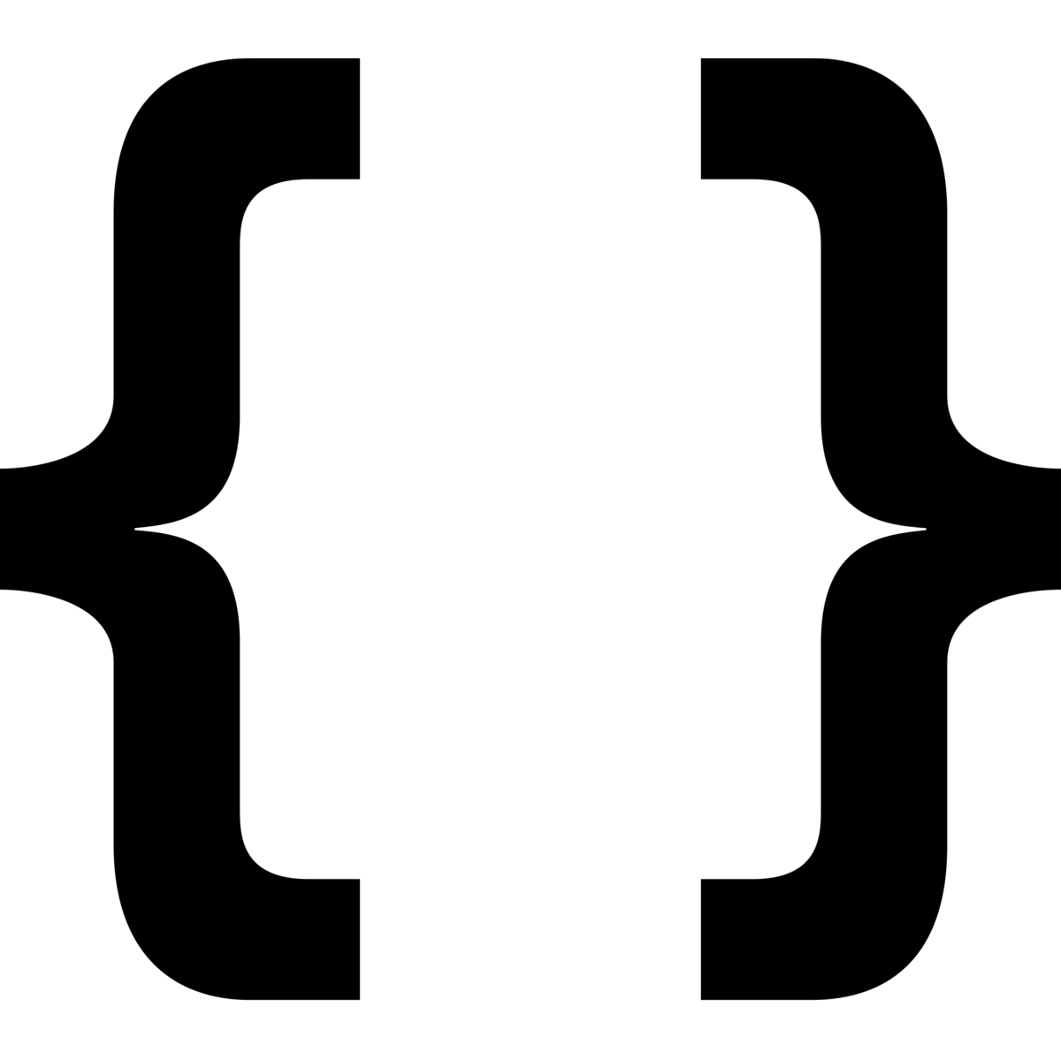

IV. Develop  
In the *Develop* phase, the team plans the technical architecture, chooses a complete software stack using existing toolkits where necessary, and implements functionality per the Feature Specification.



V. Deliver  
The *Deliver* phase is when the team hands over the final prototype. Website hosting, handing over code, and future DALI collaboration could all be part of the final deliverable.

# **Assumptions**:

This section lists various assumptions about the project and various roles such as what the partner will provide throughout the process (data, reports, blogs, etc) and what the partner can expect from the DALI team. The following should always be included in your proposal:

1. Students work for a maximum 10 hours per week on DALI projects and on a term-to-term basis within the college’s quarter system. Timelines are flexible and subject to change.
2. DALI is an educational initiative. This is a collaboration between the partner and students to both learn and create great work.
3. The partner will provide all the content - EVERY word on the finished work will be provided by the partner.
4. The partner has all the data needed, or will have it by X date.